**Experiment-4:**

Exercises to solve real world problems using the following machine learning methods:

a) Linear regression b) Logistic regression c) Binary classifier

1. Linear regression

**#Implementation**

import numpy as np

from sklearn.linear_model import LinearRegression

x = np.array([5, 15, 25, 35, 45, 55]).reshape((-1, 1))

y = np.array([5, 20, 14, 32, 22, 38])

print('x',x)

print('y',y)

model = LinearRegression()

model.fit(x, y)

#model = LinearRegression().fit(x, y)

r_sq = model.score(x, y)

print(f"coefficient of determination: {r_sq}")

print(f"intercept: {model.intercept_}")

print(f"slope: {model.coef_}")

new_model = LinearRegression().fit(x, y.reshape((-1, 1)))

print(f"intercept: {new_model.intercept_}")

print(f"slope: {new_model.coef_}")

y_pred = model.predict(x)

print(f"predicted response:\n{y_pred}")

y_pred = model.intercept_ + model.coef_ * x

print(f"predicted response:\n{y_pred}")

x_new = np.arange(5).reshape((-1, 1))

print('x_new',x_new)

y_new = model.predict(x_new)

print('y_new',y_new)

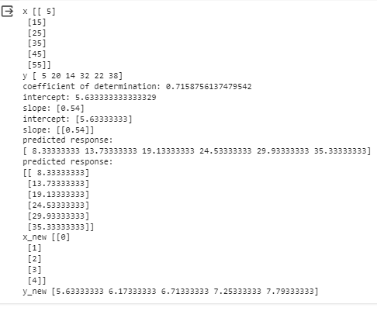

**a1)Linear model coefficients**

from scipy import stats

x = [5,7,8,7,2,17,2,9,4,11,12,9,6]

y = [99,86,87,88,111,86,103,87,94,78,77,85,86]

slope, intercept, r, p, std_err = stats.linregress(x, y)

print(r)

print(slope)

print(intercept)

print(std_err)

print(p)

#The r value ranges from -1 to 1, where 0 means no relationship, and 1 (and -1) means 100% related.

Output

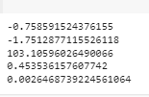

1. **Logistic Regression**

import numpy

from sklearn import linear_model

X = numpy.array([3.78, 2.44, 2.09, 0.14, 1.72, 1.65, 4.92, 4.37, 4.96, 4.52, 3.69, 5.88]).reshape(-1,1)

y = numpy.array([0, 0, 0, 0, 0, 0, 1, 1, 1, 1, 1, 1])

logr = linear_model.LogisticRegression()

logr.fit(X,y)

predicted = logr.predict(numpy.array([3.46]).reshape(-1,1))

print(predicted)

Output:

[0]

1. **Binary classifier**

**#Implementation**

import pandas as pd

import numpy as np

df = pd.read_csv('/content/sample_data/Pokemon.csv')

df.head()

df.drop(columns=['#','Name',  'Type 1', 'Type 2'],inplace=True)

df

df.Legendary.value_counts()

from sklearn import preprocessing

label_encoder = preprocessing.LabelEncoder()

df['Legendary']= label_encoder.fit_transform(df['Legendary'])

df['Legendary'].unique()

df

df.Legendary.value_counts()

from sklearn.model_selection import train_test_split

pokemon_features = df.drop("Legendary",axis=1)

target = df["Legendary"]

X_train,X_test,Y_train,Y_test = train_test_split(pokemon_features,target,test_size=0.20,random_state=0)

from sklearn.metrics import accuracy_score

from sklearn.linear_model import LogisticRegression

lr = LogisticRegression()

lr.fit(X_train,Y_train)

Y_pred_lr = lr.predict(X_test)

score_lr = round(accuracy_score(Y_pred_lr,Y_test)*100,2)

print("The accuracy score achieved using Logistic Regression is: "+str(score_lr)+" %")

